The Case of

Hitler’s Diaries

using chromatography to solve a crime

Alison Graham

Teachers notes
The case of Hitlers Diaries
Syllabus links:
Junior Certificate Science : OC2 Separate mixtures using …paper chromatography.
Leaving Certificate Chemistry: Mandatory Exp 7.7 Separation using paper chromatography
Equipment required:
Chromatography paper
Beakers
Capillary tubes or glass rods for spotting
Inks ( the inks look different colours so it is best to put them in coloured glass or wrap tubes in foil!)
Ink from diaries c10 ml Quink blue ink+ c3ml red, green and yellow food colouring
Modern ink as above
Ink from 1940’s c 10 ml Quink blue ink+c3 ml red and green food colouring.
What you need to do in advance:
Photocopy student worksheet
Prepare inks (see above
Suggested answers to questions:
2. Modern ink has additional yellow constituent compared with 1940’s ink
3. Modern ink. Could not have been written in the 1940’s
4.Suggests the diaries are forgeries. Other evidence
- Handwriting analysis
- Analysis on paper
- Investigation of Konrad Kujau
- Investigation of Gerd Heidemann
5. No it only proves that they could have been written in the 1940’s
6.
 | A | B
Rf | 1.6/3.4 = 0.47 | 2.7/5.9=0.45
Rf | 2.6/3.4 = 0.76 | 4.6/5.9 = 0.77
Rf | 3.3/3.4 = 0.97 | 5.8/5.9 = 0.98
The ink is probably the same
What actually happened!
Handwriting analysis: Experts concluded diaries were authentic but they did not realise that they were comparing the diaries with other faked versions of Hitler’s handwriting
Analysis on paper: UV light showed that the paper contained a substance only added to paper since 1954.
Together with the chromatography evidence on the ink investigators went back to Konrad Kujau. He had perfected the art of imitating Hitler’s handwriting. Heidemann was working with him for financial gain. Both were sentenced to 4 years in jail.
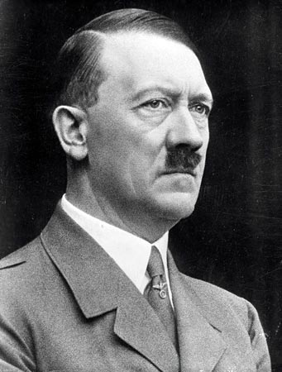
Student worksheet
The Case of Hitler’s Diaries

The crime
During the 1980’s a German publisher paid €2 million for a diary written by Hitler during the war. It was contained in 60 handwritten notebooks. The contents of the diaries were shocking. They showed that Hitler was not aware of ‘the final solution’, the Nazi extermination of Europe’s Jews. They showed that on the contrary his plan was to settle the Jews in the East.
Apparently the diaries had left Berlin in the chaos of the end of the second World War but the plane carrying them had crashed. A farmer had found the documents but unaware of what they were had stored them away in an attic. It was only when a dealer in second World War memorabilia came to the area that he remembered them and sold them. They passed through a number of dealers before they came into the possession of Konrad Kujau, a collector of Nazi documents. Kujau then took the diaries to Gerd Heidemann, a journalist on Germany’s Stern newspaper. On April 22nd 1983 Stern began to serialise their amazing discovery. They also sold publication rights to The Sunday Times in the UK and to Newsweek in America.
Doubts were raised about whether they were authentic and handwriting experts were called in to make comparisons with other known examples of Hitler’s handwriting. They concluded that the diaries were indeed authentic.
But are they? Your task is to carry out scientific comparisons of the ink used in the diary, modern ink and ink used in the 1940’s

What you need to know!
Your teacher will show you some chromatography paper.
When you place one end of it in water the water rises up the paper by capillary action- the same way as it does into a sponge or J cloth. As the water passes a drop of ink on the paper it carries the dyes in the ink with it - but some move more easily up the paper than others. The dyes therefore separate and you can see what dyes the ink contains.

☺The actual distance moved by dyes up the paper is not useful for identifying the dye as it depends on a number of variables - temperature, how long you leave it to run etc. However the ratio of the distance moved by the dye to the distance moved by the water is called the Rf value, or retention factor, and can be very useful in identifying dyes . This is why it is important to mark the original spot and the level reached by the water at the end of the experiment!
Rf = distance moved by dye/distance moved by the water
What you need to do to solve it!
You are going to use chromatography to compare ink from Hitler’s diaries with ink available in the 1940’s and modern ink.

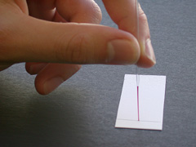
1. Mark a pencil line on the chromatography paper
2 cms from the bottom.

2. Place drops of ink on the paper as shown. You will
get best results with a small dot . Leave it to dry before
you add a second drop or the drop will get too big.

3. Make chromatograms for all the inks you wish to test.
You will fit 2 or 3 inks on each piece of
chromatography paper.

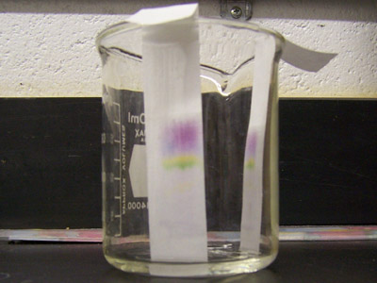
4. Place the chromatograms in a beaker with a little water as shown. Make sure the pencil line is above the level of the water.

5. When the water is near the top take them out and
mark the level the water has got to while the paper is
still wet. Make an accurate drawing on the worksheet

☺6. Measure the distance moved from the start line
by the water and each of the colours in the inks.
Calculate Rf values for each colour as described
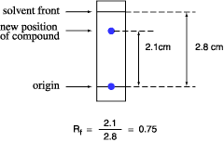
earlier.

What have you found out?

1. Draw diagrams of your chromatograms. Label the colours and the inks carefully.

2. Compare the ink from the 1940’s with the modern ink. Are they the same? If not how do they differ?
…………………………………………………………………………………………….
………………………………………………………………………………………………………………………………………………………………………………………………

3. Which ink was used to write the diaries? Could they have been written in the 1940’s?
……………………………………………………………………………………………..
……………………………………………………………………………………………..
………………………………………………………………………………………………
4. What do you think happened? What other evidence would you need to collect to prove your theory?
………………………………………………………………………………………………………………………………………………………………………………………………………………………………………………………………………………………………………………………………………………………………………………………………

5. If the diaries were written with ink from the 1940’s would it prove that they were genuine?



